

**How does A Tenancy of our property work?**

The Society continues to be responsible for the repair and maintenance of the structure and fabric of the property – including external decorating and servicing of the gas heating and hot water.

Contractors have been appointed to carry out this work. We rely on ministerial residents to inform us when an item needs attention. A 24-hour, seven-day week service is available for emergency repairs.

Responsibility for internal decoration, kitchen appliances (including fitted cookers, fridges etc) and a number of smaller items rests with the resident.

Rent is payable, with the amount reviewed annually. In 2018/19 the monthly rent for our residents is £268. Rent is payable from the date the property becomes available for occupation.

The ministerial resident is responsible for all utility bills, water charges, council tax and telephone costs. A variety of other services are available to residents including – fitting of aids and adaptations and the facility to transfer if the property is no longer suitable.

The insurance of the property is the Society’s responsibility. The ministerial resident is responsible for insurance of the contents.

**METHODIST MINISTERS’ HOUSING SOCIETY**

109 Baker Street, London W1U 6RP

020 3848 6020 • admin@mmhs.org.uk • www.mmhs.org.uk

**Our Vision**

‘There was not a single person in need among them’ – Acts 4:34

**Our Mission**

We meet the housing and housing related needs of retired Methodist ministers of limited means, and their spouses, and their widows and widowers – and offer support for their wellbeing in the key areas of mobility and independence.

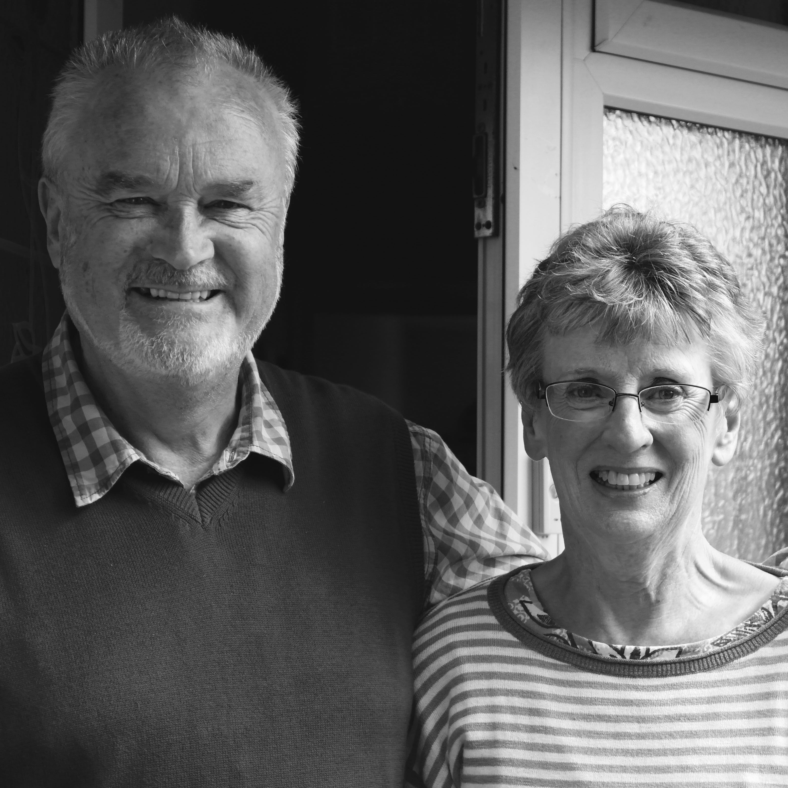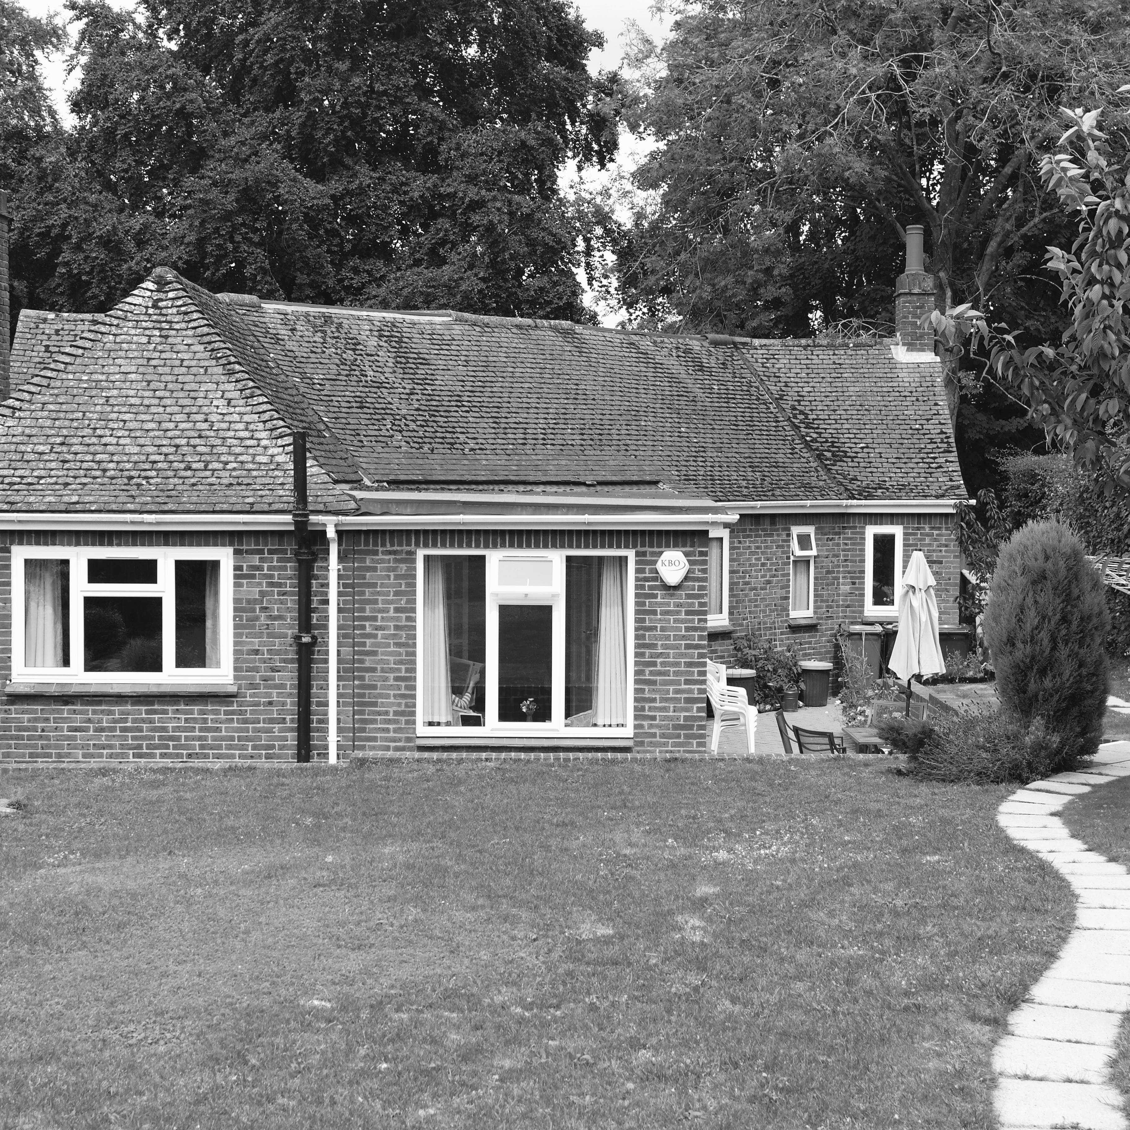

**WHAT IF I ALREADY OWN A HOME?**

As part of our mission to meet housing and housing related needs, we are now able to take equity shares ourselves in houses owned by Presbyters/Deacons. Details are available on request.

**What property is available?**

The Society has a good property portfolio and we aim to provide a home for retirement from this. You will be informed up to 18 months before your retirement date of any which are available. You will continue to be informed of any additions to this list which may be of interest to you.

If refurbishment work is required, we will arrange for this to be done in consultation with you. The refurbishment will be of a high standard, with the intention of minimising any future maintenance as well as reducing carbon emissions.

On occasion a property may be purchased, but only if there are special circumstances which require a property in a specific area which we are unable to meet from our available property portfolio.

**WHO IS eligible?**

Presbyters/Deacons on retirement, including those retiring for medical reasons.

Presbyters/Deacons must have served the required minimum of years in full-time ministry immediately prior to retirement (subject to some exceptions).

Required minimum number of years’ service is ten years. Where an applicant is retiring on medical grounds, the number of years’ service will include any years that were predicted to be worked as a Presbyter/Deacon.

To maintain the Society’s charitable status, we must demonstrate that we provide assistance to those with limited means.

In 2018/19 the maximum amount of savings an applicant may hold is £250,000 (including the value of any equity held in a property by both applicants). An applicant(s) must not have joint annual gross income in excess of £40,000 per annum.

Any applicant must contribute towards provision of home where she/he/they have more than £25,000 in savings. The amount is calculated on a sliding scale, and is converted into an equity share in the property which is reflected as a percentage of the value.

**Our Values**

We have a Christian distinctiveness of which we are proud, and it underpins who we are and what we do. Our concern is to show high standards of care in all we do – and to be professional both as individuals and as an organisation.